KASTORIA · 13.12.2021
CONFERENCE
DEPARTMENT OF COMMUNICATION AND DIGITAL MEDIA
UNIVERSITY OF WESTERN MACEDONIA
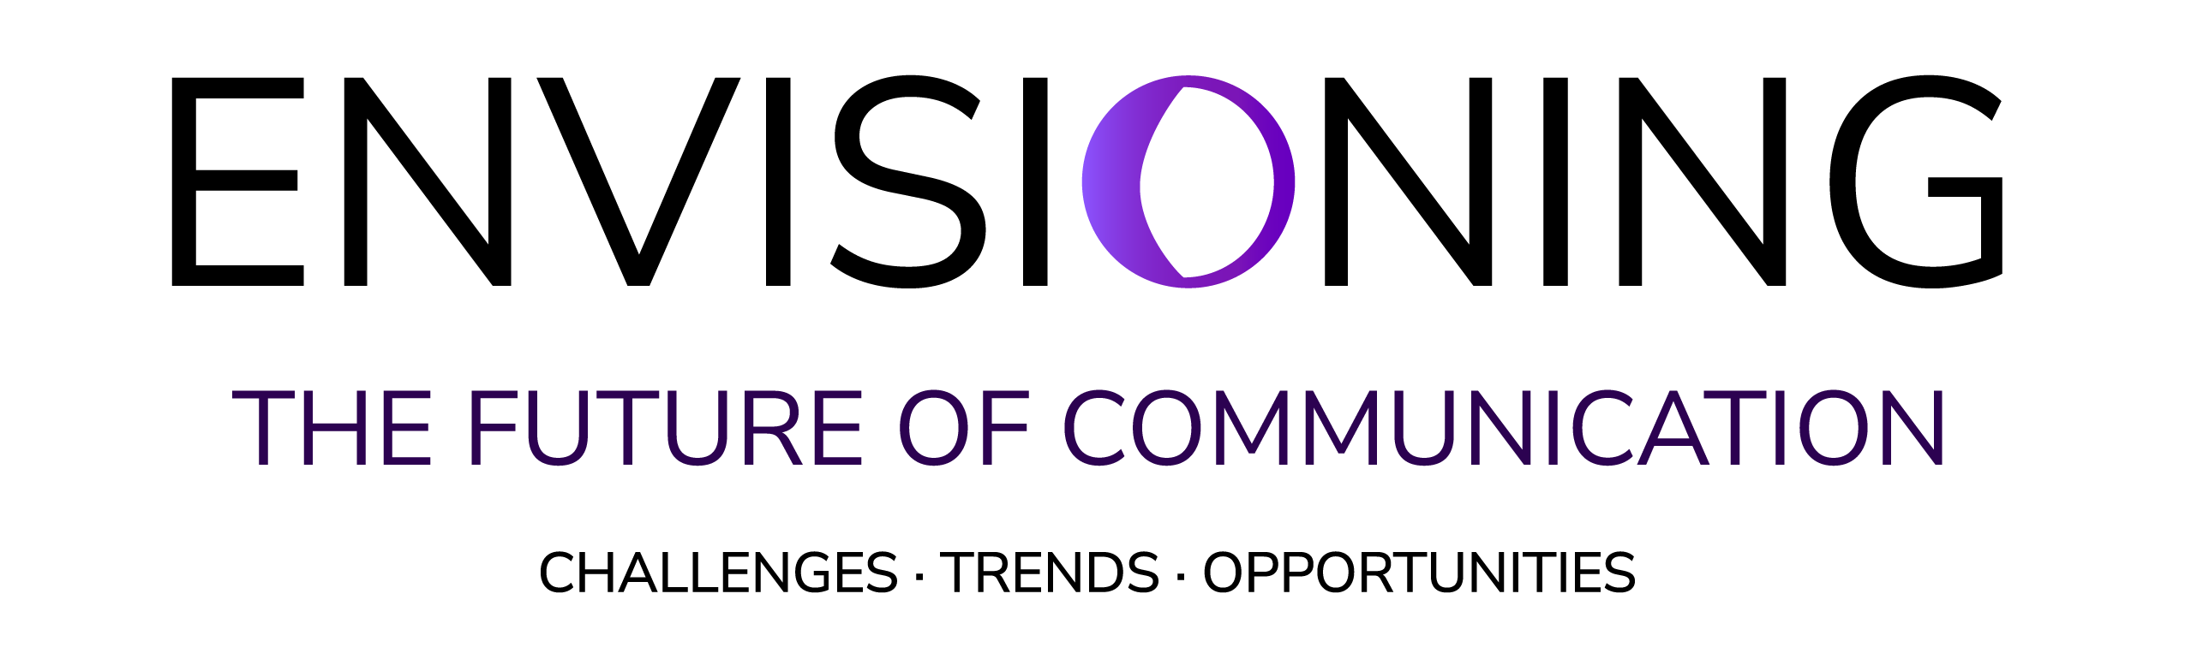

The conference aims to provide a forum for academics, researchers, and professionals to share their latest research endeavors and discuss the challenges, trends, and opportunities of the existing communication landscape with the common goal of shaping the future of Communication. The conference explores a variety of themes related but not restricted to:
- Crisis, disaster, and risk communication
- Uses of social media and mass media during crises
- Social media landscape
- Publics, fake news, and citizens’ misinformation
- Corporate communications and public relations
- Political and public communication
- Role of mass media in shaping public perceptions
We invite academic research contributions as well as professional contributions based on the main themes of the conference. The conference will be held at the campus of Kastoria for those who wish to present in person, as well as online through the Zoom platform. All sessions will be livestreamed.
The conference will be organized around four main sessions:
- Public communication in the digital age
- New technology and communication
- Corporate communication, crisis, and risk communication
- Media, Ideology and Power
Academics, researchers, and professionals wishing to present their research/work need to submit a short abstract of no more than 300 words, until November 14, 2021 at the following link:
https://forms.gle/nHiVacMdFM1GM4vH8
Abstracts need to have a title and include the main goal of the study/presentation, objectives, method (if applicable), and key findings.

Organizing Committee
Prof. Dr. Domna Michail, University of Western Macedonia
Prof. Dr. Georgios Lappas, University of Western Macedonia
Dr. Alexandros Kleftodimos Assistant Professor, University of Western Macedonia
Dr. Michalis Vrigkas Assistant Professor, University of Western Macedonia
Dr. Amalia Triantafillidou Assistant Professor, University of Western Macedonia
Dr. Stamatis Poulakidakos Assistant Professor, University of Western Macedonia
Dr. Anastasia Yannacopoulou, Assistant Professor, University of Western Macedonia
Dr Anastasia Veneti, Associate Professor, Bournemouth University
Dr Bianca Fox, Senior Lecturer, Nottingham Trent University and Visiting Lecturer, King’s College London
Technical Support
Stefanos Goutzios, Technical Staff, UoWM
Andreas Kakaris, Graduate Student, Dept. CDM

